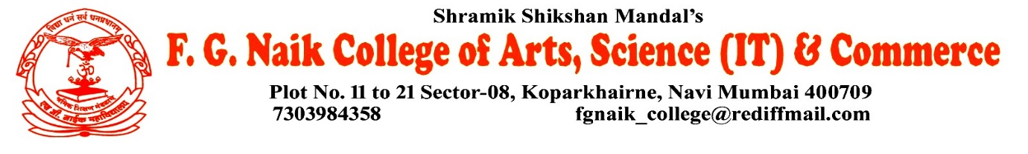

NSS UNIT
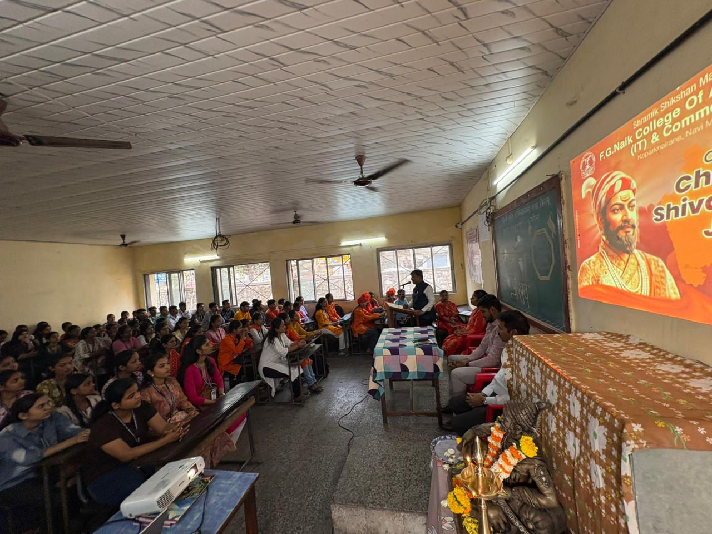
CHHATRAPATI SHIVAJI MAHARAJ JAYANTI CELEBRATION

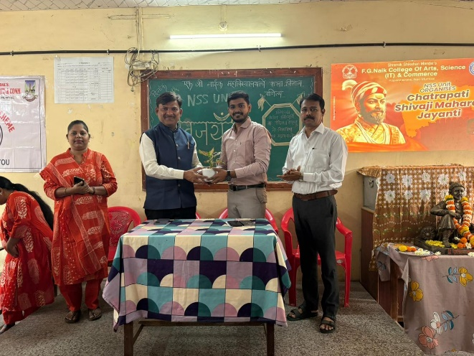
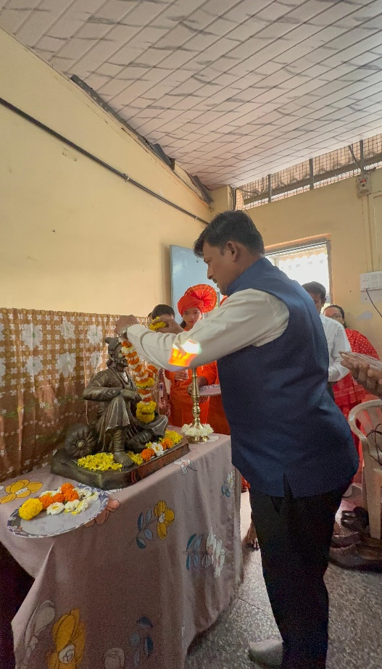

OBJECTIVE OF PROGRAM: To create awareness about the life, bravery, leadership, and values of Chhatrapati Shivaji Maharaj, and to inspire students to follow his ideals of courage, justice, good governance, and patriotism.
DATE: 18/02/2026
LOCATION: F.G Naik College
PARTICIPATING STAFF: All the NSS volunteers, teaching and the non-teaching staff of the college.
NUMBER OF VOLUNTEERS PARTICIPATING: 113
The NSS Unit organized the Chhatrapati Shivaji Maharaj Jayanti Celebration to honor the birth anniversary of the great Maratha ruler, Chhatrapati Shivaji Maharaj. He is remembered for establishing a strong and progressive kingdom and for his principles of bravery, discipline, and respect for all communities.
A lecture was conducted to explain the life, achievements, and administration of Chhatrapati Shivaji Maharaj. The speaker highlighted his courage, strategic thinking, and dedication towards the welfare of the people. Students gained valuable knowledge about his role in establishing a strong and just kingdom.
The program also included Powada singing, which presented the heroic stories of Chhatrapati Shivaji Maharaj in a traditional and inspiring manner. The performance created enthusiasm among the students and helped them understand the historical importance of his achievements.
PROGRAM DETAILS: The program commenced with a formal welcome, followed by the lecture and Powada singing dedicated to Chhatrapati Shivaji Maharaj. The event created awareness among students about his legacy and inspired them to follow his values of bravery, leadership, and patriotism.
The NSS Unit successfully conducted the Chhatrapati Shivaji Maharaj Jayanti Celebration, making the program informative and inspiring for all participants.

NSS IQAC
PROGRAM OFFICER CO-ORRDINATOR I/C PRINCIPAL

